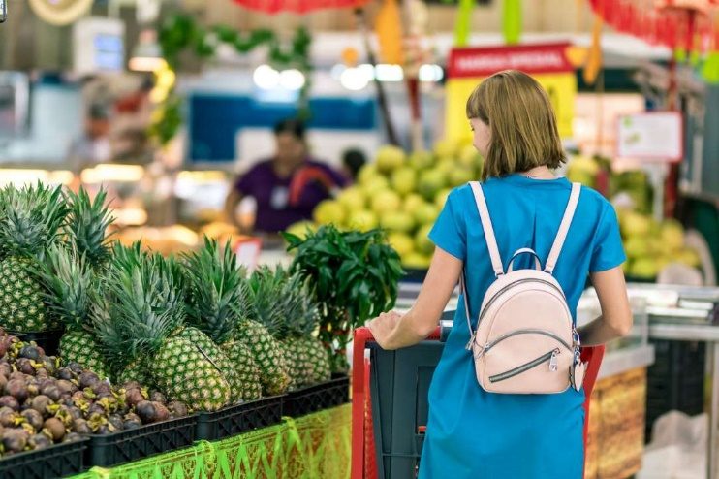

How to read food labels while shopping.
With all the choice surrounding us, making good food decisions when shopping can be challenging.
Looking at food labels
On a food package, you will find two items worth taking notice of:
1.The food ingredients list
» The first ingredients listed are the ones the product contains the most of.
» Avoid food with added sugar listed.
» Often, the longer and more complicated the ingredients list is, the more processed it is » Opt for foods that are closer to their natural form (called ‘wholefoods’).


2.The nutrition information panel
» This table displays the nutritional information/
declaration per 100g and often per portion
» It tells us the energy contained within the
food in calories (kcals)
» The nutrient breakdown includes fat,
carbohydrate, sugars, protein and salt/sodium
» Often, you’ll also see fibre here and sometimes
other nutrients.
» When comparing two or more foods, focus on
the ‘per 100g’, as the ‘per portion size’ amount differs between foods
It often also shows how much each food/product fulfills our ‘Guideline Daily Amount’ (GDA) or ‘Reference Intake’ (RI), based on a 2000 kcal diet:

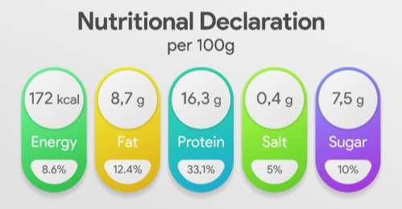

Choose wholegrain whenever possible.
» Aim for wholegrain options with your bread,rice, pasta and crispbread/crackers
Watch out for:-
» Added sugar and high dried fruit content in breakfast cereals – consider alternatives.
» Choose fresh fruit over dried fruit.
» Added sugar in dressings – use simpler ones,like balsamic vinegar and olive oil
» ‘Low fat’ claims on products, as these often contain a lot of sugar instead.
Simple tricks for a successful shop
1.
Avoid shopping when hungry
2.
Make a list before you go
3.
Ignore marketing claims
4.
Read the food labels

